**Name:** Subhadeep Mondal.

**Registration No:** 243002410612

**Department:** BSc IT Cyber Security(2024-2028)

**Roll Number:** 30085324006

Subject: Software tools and technology.

Q.2. Creat a simple document that consists of 2 section [section 1, section 2], and a paragraph with dummy text in each section. Also include header [title of the document] and footer [institute name, page number] in tha document

The code is:

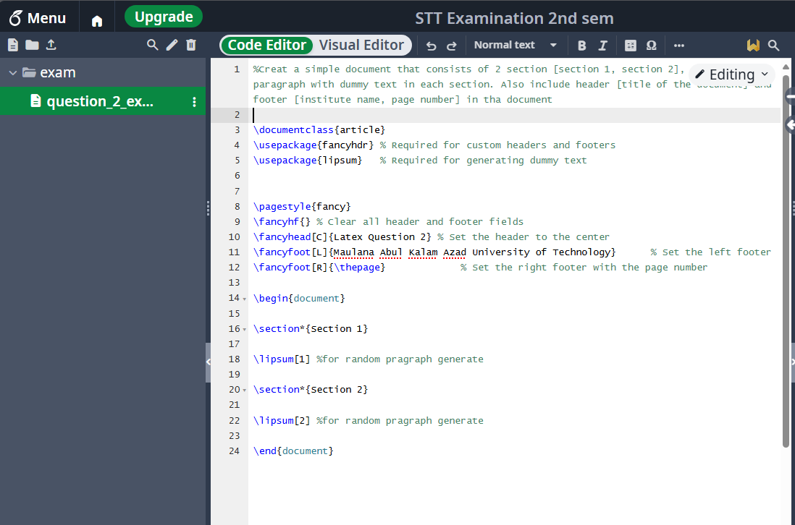

Output: